# Module: General Settings

### Section I: Software Access and Layout Lesson 1: ActiveNet Database Access

**Details:** Browse to ActiveNet Database, and log into the trainer using your login username and password

* Note: Each consultant is assigned a database for learning and testing functionality
* For maximum compatibility, use the latest version of Internet Explorer as your web browser for all activity conducted in ActiveNet (both Trainer and Live Site)
* *Tip: In total, each and every ActiveNet Database will have 4 URLs which include a Trainer Front Desk, Trainer Public Access, Live Site Front Desk and Live Site Public Access.*

### Lesson 2: Banner Tab Navigation

**Details:** Click and navigate through ActiveNet using banner tabs

* View the banner ribbon and click through the tabs at the top of the webpage:
  + Front Desk
  + Point of Sale
  + Reports
  + Communication
  + Administration
* The screenshot below displays the banner tabs in a trainer database
* Note: Banner tab layout is configurable in Administration > System Settings > Banner Tabs



### Lesson 3: Drop-down Menu Navigation

**Details:** Click and navigate through the drop-down menus, specific to each banner tab submenu

* Select a banner button, and notice the changes that occur to the drop-down menu navigation sidebar
* The picture below shows the first couple of drop down menus available for selection within the Administration Tab

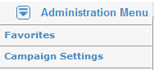

### Lesson 4: ActiveNet Tab Navigation

**Details:** Click and navigate through the tabbed browsing feature available in ActiveNet

* While having a tab (e.g., administration) open, select the plus sign on the right-hand side of the tab to open up a new tab
* The screenshot below shows multiple tabs open, similar to tabs found in a web browser

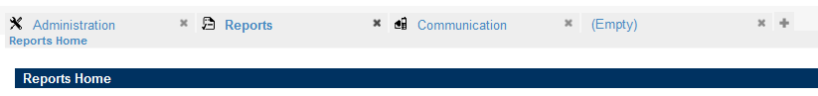

### Lesson 5: ActiveNet Help Menu Navigation

**Details:** Navigate through ActiveNet using the Banner Tabs and Drop-down Menus, privy to the existence of a smart help menu available throughout the site

* Click on the Reports tab, and navigate through the drop-down menus to get to registration reports
* Select Activity Totals report
* Select the Help link at the top right hand corner of the webpage
* Notice that the helpful information is relevant to the section where you currently reside (i.e., reports)
* *Tip: You can navigate through the help menu that opens up by using the available links, and moving back to pages using the backspace key*

### Lesson 6: Navigate to Public Access Site

**Details:** Browse to, and navigate through the Public Access Site linked to your ActiveNet trainer database

* Access your public access site by entering the URL into your web browser (IE)
* Create an account for yourself using your email address and enter all relevant information into the fields
* *Tip: Administration Home > Locations > Sites > Organization*

### Lesson 7: Uploading and Placing a Logo

**Details:**  Upload your city’s logo and place it on the Banner Tab and Receipts

* Find your city’s logo on their website and save it to your hard drive
* Upload the logo as a single file
* Navigate to the System General Configuration and select the file for both the Banner Logo and Receipt logo fields
* Note: Ensure the logo is of the appropriate size and proportions suited for the banner tab and receipts (maximum 80 px height and 250 px width) You may have to resize them in a photo editing program (e.g. Microsoft Office). You may also need to create two versions of different sizes for the banner tab and receipts.

### Lesson 8: Create a System User for you

**Details:** Create a System User for yourself that has full System Admin Permissions

* Go to System Settings > System Users and add new user
* Make sure Sys Admin is checked